THE SCHOOL
Teaching Assistant Level 2 ~ School Information
The school is named after William Allen, a Lancashire man, who was born in 1532 and is known to have lived as a young boy at Rossall near to the site of the school. His determination not to abandon his Catholic faith during the reign of Elizabeth I caused William to flee to the continent in 1565. William Allen founded the English Seminary at Douai and the English College in Rome in order that young Englishmen could be trained as priests and return to England to keep alive the Catholic faith.

We were once again oversubscribed for September 2017 having received in excess of 370 applications for the 165 places available. Our pupils come from a wide-ranging catchment area. Eight feeder Catholic Primary Schools situated in the boroughs of Wyre, Fylde and Blackpool Unitary Authority serve the school in the main. Some children travel significant distances to school from the parishes of St. Mary’s, Great Eccleston and St. William’s, Pilling. Links between Cardinal Allen and feeder primary schools have always been very strong.
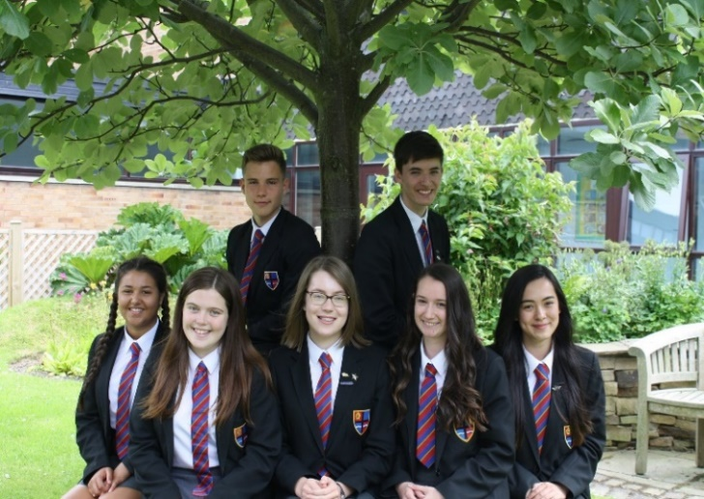
The care and welfare of our pupils are vital to us. The school is founded on the teachings of Christ and promotes a distinctive Christian ethos where every pupil is considered as unique and important. Our 810 pupils form a friendly, open school in which discipline is good and where a high value is placed on order, respect for others and endeavour. This means that we can be rightly ambitious for all our pupils and encourage them all to have high expectations.

Our school is constantly striving to achieve higher standards as reported in our most recent Ofsted Report (2015) and in our SECTION 48 Inspection Report (2017) which described us as an “Outstanding Catholic School”. We recently enhanced our status as a Fairtrade school by being designated a FairAchiever School, we are one of only twelve Eco Ambassador Schools in the country, we were recently redesignated a Full International School by the British Council and staff and pupils enjoy an annual exchange visit with our partner school in India.

Quotes from our most recent inspections include:
“Cardinal Allen is an outstanding Catholic School” (Section 48 2017)

“Pupils are proud to belong to Cardinal Allen Catholic High School; they are greatly appreciative of all that the school provides and how it supports and nurtures them. They feel encouraged and inspired to live by the school motto and be all that you can be”. (Section 48 Inspection 2017)

“The executive headteacher, headteacher, governors and senior leadership team provide outstanding leadership.” (Ofsted 2015)

“A whole-school focus on improving teaching and students’ academic and personal development has led to significant improvements across the school. The school has an excellent ability to continue to improve further.” (Ofsted 2015)

“Students behave outstandingly well. They are courteous and polite, relate very well to each other and to adults and are very happy at school. They are very enthusiastic about learning.” (Ofsted 2015)

“The behaviour and attitudes of pupils observed throughout the inspection were exemplary.” (Section 48 2017)

“The spiritual, moral, social and cultural education of students is outstanding and is an integral part of school life.” (Ofsted 2015)

“The ethos of the school is rooted firmly in the teaching of the Catholic Church. The fruits of this ethos are manifest in the pupils and staff in the school; through the very strong relationships and in the profound sense of belonging and of pride that exists.” (Section 48 2017)

THE PLACE
The Fylde Coast is a very pleasant area in which to live and work. The school is situated between Fleetwood and Cleveleys in a pleasant residential area near to Rossall Beach. This area of Lancashire forms part of the Wyre District which stretches from the towns of Fleetwood, Thornton-Cleveleys and Poulton-le-Fylde to the rural villages of Over Wyre and hills of the Trough of Bowland. A wide variety of housing is available along the Fylde Coast and the area is within easy reach of the M55 motorway which allows quick access to Preston, Manchester, the Lake District and the Yorkshire Dales. Both the cities of Preston and Lancaster are within a 30 minute drive.

LEARNING SUPPORT DEPARTMENT
The Learning Support Department is comprised of nine Teaching Assistants working at Levels 2 and 3, along with two Higher Level Teaching Assistants, the SENDCO and SENDCO Administration Assistant. As the largest department in the school, Learning Support is at the heart of Cardinal Allen, working hard to ensure that every pupil has full access to school life. In line with the SEN Code of Practice and the Equality Act 2010, we offer support for any pupil who is identified has having Special Educational Needs. Inclusion is about belonging, feeling happy and being valued within the school and wider community, irrespective of age, ability, ethnicity or social background. At Cardinal Allen we value all students as individuals with their own unique qualities. Within a nurturing and supportive environment we encourage growth, independence and self-belief, fully embracing the school's motto of 'Be All You Can Be'.

WHO WE ARE LOOKING FOR
All staff are expected to make a positive contribution to the life of the School. The aims and purposes of the School are expressed in the school’s Foundation Statement. There is a wide variety of extra-curricular activities and all staff are encouraged to become involved with this important aspect of school life. Applicants are asked to indicate particular interests and activities.

A programme of professional and pastoral support is given to all new appointments. The appointment will be based on the Catholic Education Service contract of employment which will be offered to the successful candidate by the Governors.

THE PROCESS OF APPLICATION AND INTERVIEW
Applicants should complete the CES application form. [Please only use the version of the CES application form available from the school website] Your application should be addressed to the Headteacher, Mr Cafferkey, (head@cardinalallen.co.uk) and its receipt will be acknowledged by the school. The closing date for receipt of applications is 9.00am on Monday 19th June2017 with interviews to follow.

AND FINALLY
I hope you will feel encouraged to apply for this post and I look forward to receiving your application. Should you want to discuss the post further or indeed want to visit the school, please contact Mrs Jane Abra, the school’s Business Manager.

Andrew Cafferkey
Headteacher

Teaching Assistant Level 2a ~ Job Description
Main responsibilities/Purpose:
Under the clear guidance, in respect of their work with individuals or small groups, to support the education, personal and social development of pupils in the class including those with special needs and/or bilingual needs and to establish positive relationships with pupils and assist them to complete structured learning activities. The role would be to ensure pupils remain on task and to report progress to the teacher.

In addition to the following duties, the postholder may be required to undertake any of the duties normally associated with a lower graded Teaching Assistant post
Line Manager: SENDCO
Line Managing: N/A
Liaising with: SENDCO, Mrs J Boughton & Mrs N Cardwell, the Curriculum Leader and other colleagues in a specific Department, relevant non-teaching support staff, LEA representatives, external agencies and parents.
Working Time: 190 Pupil days per year; 25 hours per week (20 hours permanent, 5 hours variable, reviewed annually), Term time only
Salary/Grade: Grade 4 SCP 13-17, Actual salary £9,379 - £10,844
Post duties:
Relating to School Mission Statement:
- In line with the explicit aims within the School Mission Statement all employees are expected to be courteous to colleagues and provide a welcoming environment to visitors and telephone callers. Cardinal Allen places the highest value on the very positive and supportive relationships which exist between teachers and between teachers and pupils. Teachers are expected to set a positive example to others in this respect.
Support for Pupils
- Under the clear guidance of the class teacher to implement structured learning activities and to assist individual/group of pupils to complete tasks.
- To undertake activities to assist in monitoring the personal, social and emotional needs of pupils.
- To develop positive relationships with pupils to assist pupil progress and attainment.
- To assist in the devising of pupil’s individual targets and their monitoring and review.
- Support pupils as part of a planned inclusion programme.
- To assist in the development of varying skills that support pupils’ learning.
- To assist in the specific medical/car needs of pupils when specific training has been undertaken.
Support for the Teacher
- To assist in the monitoring/recording of pupil progress and developmental needs.
- To assist in the production of learning resources.
- To undertake routine classroom administrative tasks including the maintenance of records.
- To assist in pupil supervision and assist in the management of pupil behaviour
- To provide information to the class teacher to assist in the planning of work programmes.
- To liaise with the school’s nominated person in respect of pupil absence.
- To assist with the arrangements for out of school learning activities including the administration of work experience.
- To provide clerical and administrative supporting including the collection and recording of money.
- Administer routine tests, assist in the invigilation of exams and undertake routine marking of pupils work.
Support for the School
- To assist in providing an atmosphere in which effective learning can take place.
- To support the promotion of positive relationships with parents, carers and outside agencies.
- To work within school policies and procedures.
- To attend staff straining as appropriate.
- To take care of their own and other people’s health and safety.
- To be aware of the confidential nature of issues related to home/pupil/teacher/school work
Support for the Curriculum
- To be familiar with the content of the school curriculum.
- To assist the delivery of educational and developmental work programmes.
- To support the use of ICT in learning activities.

Duties relating to Pastoral /Other/Specifics:
- To play a full part in the life of the school community, to support its distinctive mission and ethos and to encourage and ensure staff and students to follow this example.
Other Specific Duties:
- To support the school in meeting its legal requirements for worship.
- To continue personal development as agreed.
- To engage actively in the performance review process.
- Employees will be expected to comply with any reasonable request from a manager to undertake work of a similar level that is not specified in this job description
- This job description is current at the date shown, but in consultation with you, may be changed by the Headteacher to reflect or anticipate changes in the job commensurate with the grade and job title.

Signature Post Holder:

Signature Line Manager:

Whilst every effort has been made to explain the main duties and responsibilities of the post, each individual task undertaken may not be identified.

Teaching Assistant 2a ~ Person Specification
Selection Criteria | Essential / Desirable | To be identified by: eg application form, interview, reference etc)
Personal Attributes required (on the basis of the job description)
Qualifications
NVQ Level 2 or above qualification – appropriate to the post (or equivalent) | D | A
Experience
Experience of working with or caring for children of relevant age | E | A, I, R
Experience of working in a relevant classroom/service environment | D | A, I, R
Experience of Administrative work | D | A, I, R
Experience of supporting pupils with challenging behaviour | D | A, I, R
Knowledge and Skills
Ability to operate at a level of understanding and competence equivalent to NVQ Level 2 standard | E | A, I, R
Ability to relate well to children | E | A, I, R
Ability to work as part of a team | E | A, I, R
Good communication skills | E | A, I, R
Ability to supervise and assist pupils | E | A, I, R
Time management skills | D | A, I, R
Organisational skills | D | A, I, R
Knowledge of classroom roles and responsibilities | D | A, I, R
Knowledge of the concept of confidentiality | E | A, I, R
First Aid Certificate | D | A, I, R
Administrative skills | D | A, I, R
Good numeracy and literacy skills | E | A, I, R
Ability to make effective use of ICT | D | A, I, R
Flexible attitude to work | E | A, I, R
Other
Commitment to undertake in-service development | E | A, I
Commitment to safeguarding and protecting the welfare of children and young people | E | A, I

