THE SCHOOL
Teacher of History ~ School Information
The school is named after William Allen, a Lancashire man, who was born in 1532 and is known to have lived as a young boy at Rossall near to the site of the school. His determination not to abandon his Catholic faith during the reign of Elizabeth I caused William to flee to the continent in 1565. William Allen founded the English Seminary at Douai and the English College in Rome in order that young Englishmen could be trained as priests and return to England to keep alive the Catholic faith.

We were once again oversubscribed for September 2017 having received in excess of 370 applications for the 165 places available. Our pupils come from a wide-ranging catchment area. Eight feeder Catholic Primary Schools situated in the boroughs of Wyre, Fylde and Blackpool Unitary Authority serve the school in the main. Some children travel significant distances to school from the parishes of St. Mary’s, Great Eccleston and St. William’s, Pilling. Links between Cardinal Allen and feeder primary schools have always been very strong.
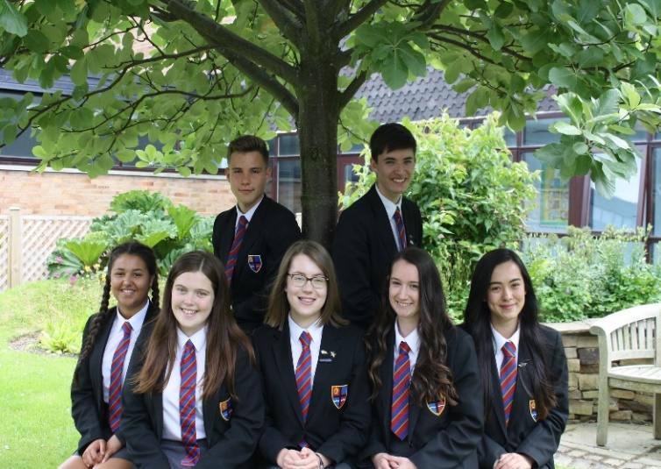
The care and welfare of our pupils are vital to us. The school is founded on the teachings of Christ and promotes a distinctive Christian ethos where every pupil is considered as unique and important. Our 810 pupils form a friendly, open school in which discipline is good and where a high value is placed on order, respect for others and endeavour. This means that we can be rightly ambitious for all our pupils and encourage them all to have high expectations.

Our school is constantly striving to achieve higher standards as reported in our most recent Ofsted Report (2015) and in our SECTION 48 Inspection Report which described us as an “Outstanding Catholic School”. We recently enhanced our status as a Fairtrade school by being designated a FairAchiever School, we are one of only twelve Eco Ambassador Schools in the country, we were recently redesignated a Full International School by the British Council and staff and pupils enjoy an annual exchange visit with our partner school in India.

Quotes from our most recent inspections include:
“Cardinal Allen is an outstanding Catholic School” (Section 48 Inspection)

“Students make an outstanding contribution to this school and gain a corresponding benefit from it”. (Section 48 Inspection)

“The executive headteacher, headteacher, governors and senior leadership team provide outstanding leadership.” (Ofsted)

“A whole-school focus on improving teaching and students’ academic and personal development has led to significant improvements across the school. The school has an excellent ability to continue to improve further.” (Ofsted)

“Students behave outstandingly well. They are courteous and polite, relate very well to each other and to adults and are very happy at school. They are very enthusiastic about learning.” (Ofsted)

“The spiritual, moral, social and cultural education of students is outstanding and is an integral part of school life.” (Ofsted)

Pupil quote: “I am very proud to wear the badge of Cardinal Allen on my blazer”. (Section 48 Inspection)

THE PLACE
The Fylde Coast is a very pleasant area in which to live and work. The school is situated between Fleetwood and Cleveleys in a pleasant residential area near to Rossall Beach. This area of Lancashire forms part of the Wyre District which stretches from the towns of Fleetwood, Thornton-Cleveleys and Poulton-le-Fylde to the rural villages of Over Wyre and hills of the Trough of Bowland. A wide variety of housing is available along the Fylde Coast and the area is within easy reach of the M55 motorway which allows quick access to Preston, Manchester, the Lake District and the Yorkshire Dales. Both the cities of Preston and Lancaster are within a 30 minute drive.

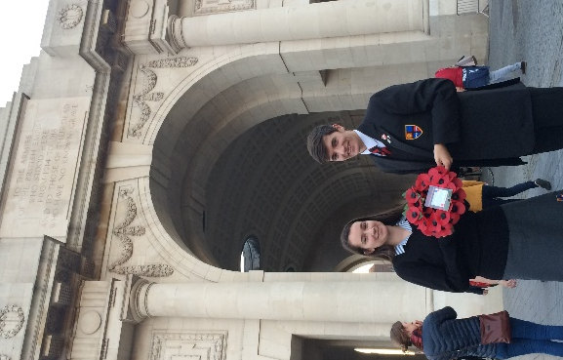
THE HUMANITIES FACULTY
History and Geography are both taught as part of the Humanities Faculty by subject specialists led by Mr Dan Sutcliffe (Assistant Headteacher/Curriculum leader), supported by two Lead Teachers Mrs Jo McMahon (History) and Miss Anne-Marie Brown (Geography). Pupils are offered a broad range of History studies, which enthuse and interest pupils ensuring that they leave school with a good grounding in British, European and World History.

The department has a vibrant mix of innovative and traditional teaching. Lesson observations show that standards among the team are very high; however, this does not mean that the team is not committed to further improvement. The department has a strong team spirit and sense of mutual support, as well as a passion for the subject and a commitment to deliver a curriculum that allows each pupil to reach his or her potential. We know that even higher standards can be achieved and existing team members are very supportive of initiatives to change and improve. Our new colleague, whether an NQT or someone with experience, will receive all the support and encouragement necessary to make a difference to our pupils and develop professionally for the next stage of his/her career.

Departmental classrooms are grouped together in the main school building and the department has an office and ample storage space. Each classroom is equipped with a desktop computer and interactive whiteboard.

CURRICULUM STRUCTURE
The school works to a 25 x 1 hour period week. At KS3, Year 7 pupils enjoy 3 hours of History over 2 weeks, while Years 8 and 9 pupils have 2 hours per week. At KS4, Year 10 pupils have two hours per week and Year 11 three hours per week. In years 7-9 pupils are banded according to KS2 results and CAT scores. In years 10 and 11, pupils are set by the History team across option blocks according to their ability, potential and progress. GCSE History is often the most popular option amongst pupils with four examination groups each year. Pupils currently study the Edexcel GCSE History Course (2016).
WHO ARE WE LOOKING FOR?
We are an ambitious school and want the very best for the youngsters in our care. The successful candidate must be able to demonstrate a commitment to change as well as the ability to take risks in moving forward.

We are looking for someone with a sense of vision, enthusiasm and energy, with the ability to contribute to the work of a very successful team. As a teacher, there must be an enthusiasm for, and commitment to, the teaching of History. The successful candidate will be expected to teach the full ability and age range including the preparation of senior classes for GCSE History. The range of duties applying to all Teachers at Cardinal Allen is defined in the enclosed Job Description.
All staff are expected to make a positive contribution to the life of the School. The aims and purposes of the School are expressed in the school’s Foundation Statement. There is a wide variety of extra-curricular activities and all staff are encouraged to become involved with this important aspect of school life. Applicants are asked to indicate particular interests and activities.

A programme of professional and pastoral support is given to all new appointments. The appointment will be based on the Catholic Education Service contract of employment which will be offered to the successful candidate by the Governors. Whilst a Catholic school, the Governors’ primary task is to appoint the very best History teacher, one who will, whether Catholic or otherwise, support and promote our distinctive Catholic ethos.

YOUR APPLICATION
Applicants must complete the CES application form together with a supporting letter of no more than two sides of A4. [Please only use the version of the CES application form available from the school website] In your letter of application, please outline how your experiences to date have prepared you for this role, including details of how you ensure all students have the opportunities to realise their full potential in History. If you are already an experienced teacher, please also indicate your success in securing the best possible outcomes in public examinations for your pupils in History by means of value-added outcomes. Your application should be addressed to the Headteacher, Mr Cafferkey, and its receipt will be acknowledged by the school. The closing date for receipt of applications is 9.00am on Wednesday 26th April 2017 with interviews to follow.

AND FINALLY
I hope you will feel encouraged to apply for this post and I look forward to receiving your application. We welcome applications from ambitious teachers, whether experienced or NQTs, and our mission is to appoint the best available candidate. Should you want to discuss this opportunity further or indeed want to visit the school, please do not hesitate to contact me.

Andrew Cafferkey
Headteacher

Teacher of History ~ Job Description
JOB DESCRIPTION FOR: | Teacher of History | Name:
Main responsibilities/Purpose:
- To implement and deliver an appropriately broad, balanced, relevant and differentiated curriculum for students and to support a designated subject area(s) as appropriate.
- To monitor and support the overall progress and development of students as a teacher/ Form Tutor
- To facilitate and encourage a learning experience which provides students with the opportunity to achieve their individual potential.
- To contribute to raising standards of student attainment.
- To share and support the school’s responsibility to provide and monitor opportunities for personal and academic growth.
Line Manager: Curriculum Leader or Lead Teacher
Line Managing: N/A
Liaising with: Curriculum Leader and other colleagues in Department, relevant non-teaching support staff, LEA representatives, external agencies and parents.
Working Time: 190 Pupil days per year; full-time; 5 In-service days; Directed time as detailed by Headteacher
Target Teaching Load: 22/25 (NQT 20/25)
Salary/Grade: Main Scale
Position on Pay Scale (highlight): NQT Main Pay Range Upper Pay Range Leadership Administrative
Post duties ( + TLR if applicable):
Relating to School Mission Statement:
- In line with the explicit aims within the School Mission Statement all employees are expected to be courteous to colleagues and provide a welcoming environment to visitors and telephone callers. Cardinal Allen places the highest value on the very positive and supportive relationships which exist between teachers and between teachers and pupils. Teachers are expected to set a positive example to others in this respect.

Operational/ Strategic Planning
- To assist in the development of appropriate syllabuses, resources, schemes of work, marking policies and teaching strategies in the Curriculum Area and Department.
- To contribute to the Curriculum Area and department’s development plan and its implementation.
- To plan and prepare lessons in the short and medium term time frame.
- To contribute to the whole school’s planning activities.

Curriculum Provision:
- To assist the Curriculum Leader, Lead Teacher [where appropriate] the Assistant Headteacher Curriculum, to ensure that the curriculum area provides a range of teaching which complements the school’s strategic objectives.

Curriculum Development:
- To assist in the process of curriculum development and change so as to ensure the continued relevance to the needs of students, examining and awarding bodies and the school’s Mission and Strategic Objectives

Staffing / Staff Development / Recruitment/ Deployment of Staff
- To take part in the school’s staff development programme by participating in arrangements for further training and continuing professional development.
- To continue personal development in the relevant areas including subject knowledge and teaching methods.
- To engage actively in the Performance Management Review process.
- To ensure the effective/efficient deployment of classroom support
- To work as a member of a designated team and to contribute positively to effective working relations within the school.

Quality Assurance:
- To help to implement school quality procedures and to adhere to those.
- To contribute to the process of monitoring and evaluation of the curriculum area/department in line with agreed school procedures, including evaluation against quality standards and performance criteria. To seek/implement modification and improvement where required.
- To review from time to time methods of teaching and programmes of work.
- To take part, as may be required, in the review, development and management of activities relating to the curriculum, organisation and pastoral functions of the school.

Management Information:
- To maintain appropriate records and to provide relevant accurate and up-to-date information for attendance, assessments and registers.
- To complete the relevant documentation to assist in the tracking of students.
- To track student progress and use information to inform teaching and learning.

Communications:
- To communicate effectively with the parents of students as appropriate.
- Where appropriate, to communicate and co-operate with persons or bodies outside the school.
- To follow agreed policies for communications in the school.

Marketing and Liaison:
- To take part in marketing and liaison activities such as Open Evenings Parents Evenings, Review days and liaison events with partner schools.
- To contribute to the development of effective subject links with external agencies.

Management of Resources:
- To contribute to the process of the ordering and allocation of equipment and materials.
- To assist the Curriculum Leader and Assistant Headteacher Curriculum to identify resource needs and to contribute to the efficient/effective use of physical resources.
- To co-operate with other staff to ensure a sharing and effective usage of resources to the benefit of the School, department and the students

UPS 2 or UPS 3 duties (if applicable): to be determined on appointment
Duties related to Teaching & Learning:
The Teachers’ Standards document gives a full description of teacher competencies at different levels. This will be referred to when making judgements on the quality of teaching and performance generally under Appraisal/Performance Management regulations. http://www.education.gov.uk/schools/teachingandlearning/reviewofstandards
- To undertake a pro rata appropriate programme of teaching in accordance with the duties of a standard scale teacher.
- To teach students according to their educational needs, including the setting and marking of work to be carried out by the student in school and elsewhere.
- To assess, record and report on the attendance, progress, development and attainment of students and to keep such records as are required.
- To provide, or contribute to, oral and written assessments, reports and references relating to individual students and groups of students.
- To ensure that ICT, Literacy, Numeracy and school subject specialism(s) are reflected in the teaching/learning experience of students
- To undertake a designated programme of teaching.
- To ensure a high quality learning experience for students which meets internal and external quality standards.
- To prepare and update subject materials.
- To use a variety of delivery methods which will stimulate learning appropriate to student needs and demands of the syllabus.
- To maintain discipline in accordance with the school’s procedures, and to encourage good practice with regard to punctuality, behaviour, standards of work and homework.
- To undertake assessment of students as requested by external examination bodies, departmental and school procedures.
- To mark, grade and give written/verbal and diagnostic feedback as required.
- To make appropriate provision for pupils with Special Educational Needs based on the I.E.P.’s produced in conjunction with the Learning Support Department.

Duties relating to Pastoral /Other/Specifics:
To play a full part in the life of the school community, to support its distinctive mission and ethos and to encourage and ensure staff and students to follow this example.
Other Specific Duties:
- To support the school in meeting its legal requirements for worship.
- To continue personal development as agreed.
- To engage actively in the performance review process.
- To undertake any other duty as specified by STPCD not mentioned in the above.
- Employees will be expected to comply with any reasonable request from a manager to undertake work of a similar level that is not specified in this job description
- This job description is current at the date shown, but, in consultation with you, may be changed by the Headteacher to reflect or anticipate changes in the job commensurate with the grade and job title.
Signature Post Holder:
Signature Line Manager:
Whilst every effort has been made to explain the main duties and responsibilities of the post, each individual task undertaken may not be identified.

Teacher of History ~ Person Specification
Cardinal Allen Catholic High School is committed to safeguarding and promoting the welfare of children and young people and expects all staff and volunteers to share this commitment. The successful applicant will be required to complete an enhanced DBS check.

The successful candidate will need to be able to articulate a clear vision for the teaching of English as well as the ability to make a contribution to whole school activities. The Governors will consider applications on the basis of each candidate's ability to meet the following criteria:
Selection Criteria | Essential / Desirable
Qualifications
Qualified Teacher Status | E
Recognised and relevant degree or Equivalent | E
Evidence of appropriate personal and professional development | E
Experience
If a trainee teacher – successful placements | E
If a serving teacher - successful preparation of candidates for public examination | E
Involvement in the development of the History curriculum | E
Knowledge and Skills
The ability to communicate effectively, both through speaking and writing to a variety of audiences. | E
The ability to provide effective support to staff, as well as be approachable, reliable and confidential | E
The ability to work effectively with a range of people, including pupils, colleagues and parents | E
Understand the use and application of ICT in a range of contexts | D
The purposes of the History curriculum and relationship to the whole school curriculum | E
An understanding of the evaluation of standards of teaching and learning in History and dissemination of good practice-particularly in relation to Appraisal | D
An awareness of development planning and target setting | E
Efficient and effective administrative and organisational skills | E
Personal Qualities
Personal impact and presence | E
Adaptability to changing circumstances and new ideas and an ability to challenge the status quo | E
High levels of motivation and a commitment to high standards | E
Analytical, creative and flexible thinking | E
Work under pressure: meet deadlines | E
Prioritise and manage their own time effectively | E
Reliability and integrity | E
Self confidence | D
The ability to promote team values and encourage others to do the same | D
Capacity to promote and support an atmosphere of co-operation and mutual support | E
Personal impact and presence | E
Commitment
A Baptised Catholic | D
A willingness to support and uphold the Catholic ethos of the school. This would be evident in the positive contribution made to the prayer and worship life of the school. | E
To equal opportunities | E
Willing to participate fully in the life of the school and contribute to the extra-curricular programme | E

Application Form and Supporting Statement:
The application form must be fully completed and legible. The supporting statement should be clear, concise and related to the specific post.

References:
Candidates are required to provide the details of referees, as detailed on the application form, who will provide a positive recommendation in support of an application for this post.

