THE SCHOOL
School Chaplain ~ School Information
The school is named after William Allen, a Lancashire man, who was born in 1532 and is known to have lived as a young boy at Rossall near to the site of the school. His determination not to abandon his Catholic faith during the reign of Elizabeth I caused William to flee to the continent in 1565. William Allen founded the English Seminary at Douai and the English College in Rome in order that young Englishmen could be trained as priests and return to England to keep alive the Catholic faith.

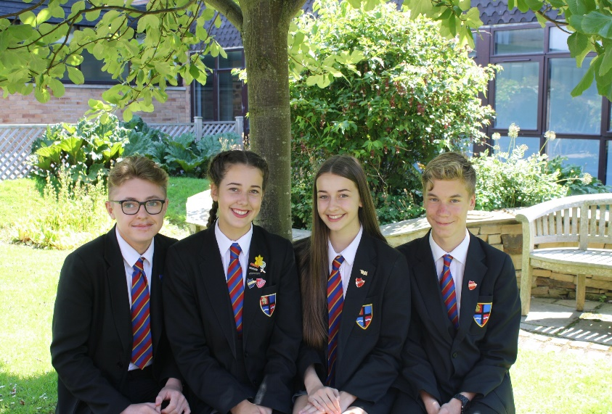
Our pupils come from a wide-ranging catchment area. Eight feeder Catholic Primary Schools situated in the boroughs of Wyre, Fylde and Blackpool Unitary Authority serve the school in the main. Some children travel significant distances to school from the parishes of St. Mary’s, Great Eccleston and St. William’s, Pilling. Links between Cardinal Allen and feeder primary schools have always been very strong and we were once again oversubscribed for September 2017.

The care and welfare of our pupils are vital to us. The school is founded on the teachings of Christ and promotes a distinctive Christian ethos where every pupil is considered as unique and important. Our 810 pupils form a friendly, open school in which discipline is good and where a high value is placed on order, respect for others and endeavour. This means that we can be rightly ambitious for all our pupils and encourage them all to have high expectations.

Our school is constantly striving to achieve higher standards as reported in our most recent Ofsted Report (2015) and in our recent SECTION 48 Inspection Report (March 2017) which described us as an “Outstanding Catholic School”. We recently enhanced our status as a Fairtrade school by being designated a FairAchiever School, we are one of a limited number of Eco International Schools in the country, we were recently redesignated a Full International School by the British Council and staff and pupils enjoy an annual exchange visit with our partner school in India.

CHAPLAINCY
The Chaplaincy at Cardinal Allen is genuinely at the heart of the school! We have two strong CAFOD groups which organise fundraisers, deliver assemblies and run campaigns promoting global justice issues. The Chaplain is supported by a group of Pupil Chaplains who prepare and deliver liturgies, produce dramas, write prayers and act as positive role models to their peers. They have made outstanding contributions to Deanery events and activities, providing their own creative responses appropriate to the liturgical season. There is also the opportunity to support the Fairtrade Group and Eco Group in providing primary assemblies at key times of the year.

We run many school-wide initiatives, such as art and prayer competitions, decorating form room doors for important Church events and CAFOD campaigns and petitions. The Chaplain is the driving force behind our Chapel Assemblies - 15 minute liturgies each morning in the Chapel that each student attends once a fortnight.

Cardinal Allen students make an outstanding contribution to charities. The School Council oversees the school’s fundraising activities and makes the decisions as to which good causes should be the beneficiaries of their hard work. During Lent, over £2,000 was raised for two local food banks, and last year we sent £1,200 to CAFOD. We have an annual collection of clothes and toiletries for the homeless, tins for the food bank and school equipment for Mary’s Meals. We also donated over £1,000 to Castlerigg Manor retreat centre towards the cost of their refurbishment project and contributed £500 to another Catholic school elsewhere in the Diocese in need of some support. All of this is on top of year group fundraising, where students get to choose the charity they wish to raise money for and organise their own fundraising events.

The Chaplaincy offers several trips for pupils. There is the opportunity to visit Castlerigg Manor, the Diocesan residential retreat centre in Year 9 and Year 11, as well as trips to the Flame conference in London, and joining the community group at WE Day at Wembley. The Chaplaincy also runs many day trips, such as to the food bank, Beacon Fell country park and pilgrimages to the shrine at Ladyewell. Our Year 11 pupils also support the Diocesan Pilgrimage to Lourdes.

We have very strong links with our local community and support our Deanery parishes with sacramental preparation, Youth Sunday celebrations and Advent Services. We also enjoy welcoming members of the local community into school for Masses and celebrations. Pupils have the opportunity to work with our partner primary schools to prepare for liturgical events and deliver prayer workshops to small groups of pupils.

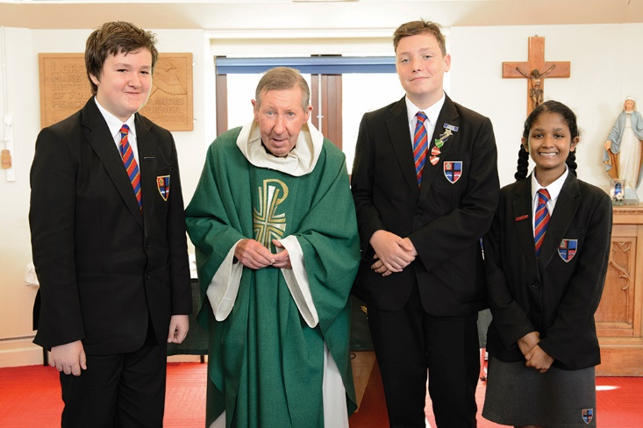
Prayer and worship are central to the life of Cardinal Allen School. The Chaplain is responsible for producing a weekly PowerPoint of reflections to support form groups in their daily act of worship. Each class also has a box of prayer resources, including a copy of the school prayer book, to support class worship. There are several occasions in the year when the whole school gathers to pray together, including whole school Masses at Christmas and the end of the year. We also have Mass every Friday morning before school to which all are welcome, and everyone prays together in assembly and form times. There are services to mark special events throughout the year, such as Harvest Fast Day, Holocaust Memorial Day and Fairtrade Fortnight. The students are very much involved in the preparation and delivery of prayer and liturgy across school.

YOUR LETTER OF APPLICATION
Please outline, in no more than two sides of A4, how your experiences to date have prepared you for this role.

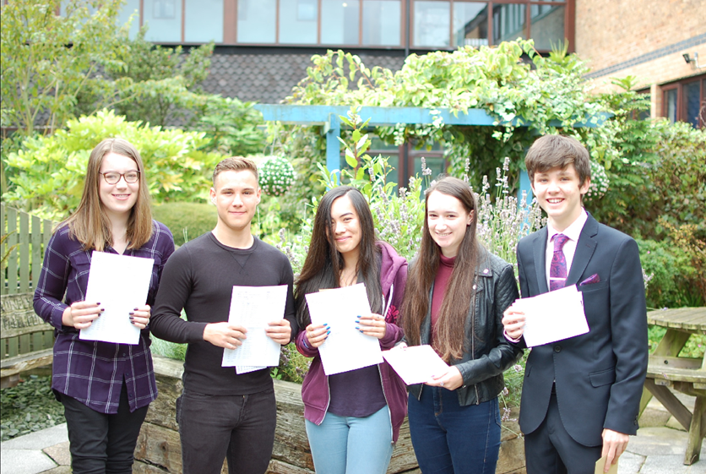
A sense of vision, enthusiasm, energy and passion will be looked for as well as the abilities needed to develop a spirit of teamwork. All staff are expected to make a positive contribution to the life of the School. The aims and purposes of the School have been expressed in the enclosed paper on 'The Foundation of the School'. There is a wide variety of extra-curricular activities and all staff are encouraged to become involved with this important aspect of school life.

A programme of professional and pastoral support is given to all new appointments. The appointment will be based on the Catholic Education Service contract of employment which will be offered to the successful candidate by the Governors. The Governors are seeking to appoint a practising Catholic who will support, promote and further develop our distinctive Catholic ethos.

Quotes from our most recent inspections include:
“Cardinal Allen is an outstanding Catholic School” (Section 48 2017)

“Pupils are proud to belong to Cardinal Allen Catholic High School; they are greatly appreciative of all that the school provides and how it supports and nurtures them. They feel encouraged and inspired to live by the school motto and be all that you can be”. (Section 48 Inspection 2017)

“The executive headteacher, headteacher, governors and senior leadership team provide outstanding leadership.” (Ofsted 2015)

“A whole-school focus on improving teaching and students’ academic and personal development has led to significant improvements across the school. The school has an excellent ability to continue to improve further.” (Ofsted 2015)

“Students behave outstandingly well. They are courteous and polite, relate very well to each other and to adults and are very happy at school. They are very enthusiastic about learning.” (Ofsted 2015)

“The behaviour and attitudes of pupils observed throughout the inspection were exemplary.” (Section 48 2017)

“The spiritual, moral, social and cultural education of students is outstanding and is an integral part of school life.” (Ofsted 2015)

“The ethos of the school is rooted firmly in the teaching of the Catholic Church. The fruits of this ethos are manifest in the pupils and staff in the school; through the very strong relationships and in the profound sense of belonging and of pride that exists.” (Section 48 2017)

THE PLACE
The Fylde Coast is a very pleasant area in which to live and work. The school is situated between Fleetwood and Cleveleys in a pleasant residential area near to Rossall Beach. This area of Lancashire forms part of the Wyre District which stretches from the towns of Fleetwood, Thornton-Cleveleys and Poulton-le-Fylde to the rural villages of Over Wyre and hills of the Trough of Bowland. A wide variety of housing is available along the Fylde Coast and the area is within easy reach of the M55 motorway which allows quick access to Preston, Manchester, the Lake District and the Yorkshire Dales. Both the cities of Preston and Lancaster are within a 30 minute drive and many staff make such daily journeys.

THE PROCESS OF APPLICATION AND INTERVIEW
Applicants must complete the CES application form together with a supporting letter of no more than two sides of A4. [Please only use the version of the CES application form available from the school website] Your application should be addressed to the Headteacher, Mr Cafferkey, (head@cardinalallen.co.uk) and its receipt will be acknowledged by the school. The closing date for receipt of applications is 9.00am on Wednesday 21st February 2018 with interviews to follow.

THE SALARY
The job is term time plus five days and the starting salary, in monetary terms, will be in the range of £17,399 to £20,215 depending on whether Grade 6 or Grade 7. As indicated in the advert, I would be very happy to talk to potential candidates about a part-time role, in excess of 25 hours per week, if such an arrangement suited both the needs of the school and the individual concerned.

AND FINALLY
I hope you will feel encouraged to apply for this post and I look forward to receiving your application. We welcome applications from ambitious and passionate individuals and our mission is to appoint the best available candidate to this key role in our school. Should you want to discuss the post further or indeed want to visit the school, please do not hesitate to contact me.

Andrew Cafferkey
Headteacher

Aim of the post: To lead the formal and informal expression of Christian ethos and worship at Cardinal Allen and to support the spiritual life of the school community.
School Chaplain ~ Job Description

Line Manager: Curriculum Leader for RE

Liaising with: Headteacher and SLT

Working Time: 37 hours term time only plus five days (Paid for 45.05 weeks) although the nature of the role will necessitate some flexibility
(Applications for a part-time role, in excess of 25 hours, would be considered – please call the Headteacher to discuss prior to application)

Salary / Grade: Grade 6 (Pts 21-26) or Grade 7 (Pts 26-31) for an exceptional candidate

MAIN DUTIES
Relating to School Mission Statement:
In line with the explicit aims within the School Mission Statement all employees are expected to be courteous to colleagues and provide a welcoming environment to visitors and telephone callers. Cardinal Allen places the highest value on the very positive and supportive relationships which exist between adults and between adults and children. The School Chaplaincy Coordinator has a high profile in this regard and as such is expected to set a positive example to others.

Core responsibilities:
- To lead in the development and use of whole school liturgy
- To lead our mission in relation to Justice and Peace
- To provide outreach community support for other schools and parishes
- To support the spiritual development of the school and its wider community
- To contribute to the pastoral care of the whole school community
- To provide advice, guidance and support for the teaching and learning of Religious Education

KEY TASKS
Lead in the development and use of whole school liturgy:
- Establish formal liturgies which will form part of our programme of Assemblies and Form time reflections.
- Lead the organisation and planning for formal acts of worship, including school Masses and community celebrations such as Confirmation services.
- Organise the schedule of assemblies for both the Hall and Chapel and contribute to their delivery. Support colleagues in preparing assemblies and contribute to whole school assemblies as appropriate.
- Support, monitor and oversee Form Time reflections.
- Ensure that the liturgical calendar/seasons are publicly and creatively celebrated within the life of the school (including in display, celebrations and electronic communications – e.g. website etc.).
- Enrich and develop the quality of corporate worship drawing on the creative gifts and resources within the school community.
- Assist in the compilation of a ‘Cardinal Allen music collection’ of songs and music for worship suitable for use by pupils, parents and staff.
- Develop a range of short informal liturgies / prayers appropriate for use by pupils, parents and staff.

Contributing to the pastoral care of the whole school community:
- Provide individual support to identified pupils and staff as appropriate
- To provide a ‘pastoral presence’ within the school community
- Lead and manage specific group support programmes (such as bereavement groups etc.)
- To channel/train support / volunteers from local parishes as appropriate
- Work with Progress Leaders to provide peer mentoring for pupils as appropriate.
- To contribute to the development of pastoral systems so that they reflect Christian principles

Contribution to the teaching and learning:
- Lead discussions within RE and PSHCEE lessons where appropriate
- To contribute to the review and implementation of the Human Relationships and Sex Education policy and to support the maintenance of an overview of the schools formal and informal curriculum in line with this
- Make formal presentations to support the curriculum as appropriate
- To liaise with Curriculum Leader for RE over the use of the Chapel as a creative learning space
- Support focused prayer, catechesis, teaching and discussion groups

Mission - Justice and Peace:
- Support activities relating to CAFOD and other appropriate charities
- To identify creative ways that the school could support such projects
- To advise on fundraising activities at the school as part of the planning process and the school calendar

Mission - Community Outreach:
- To maintain links with the local Parishes, Deanery and Diocese as appropriate
- To maintain and develop our relationship with our partner primary schools and pursue links as appropriate
- To identify areas of community service related to local faith communities which may be undertaken by the school or individuals within the school
- To undertake tasks identified by partner organisations relating to their mission

To support spiritual development of the school and its wider community:
- Develop additional pupil / staff groups as appropriate
- Plan and organise a programme of retreats for groups of pupils / staff as appropriate
- Lead on the annual Inset day dedicated to ethos and spirituality
- Organise and contribute to the schedule of Chapel briefings
- Oversee the development of the Chapel as a spiritual focus of the school
- Encourage and support the awareness and understanding of faith practice across the whole school community
- Support the private prayer life and reflectiveness of the whole school community

Other Specific Duties:
- Support the school in meeting its legal requirements for collective worship
- Continue personal development as agreed
- Engage actively in the performance review process
- Whilst every effort has been made to explain the main duties and responsibilities of the post, each individual task undertaken may not be identified
- Employees will be expected to comply with any reasonable request from a manager to undertake work of a similar level that is not specified in this job description

This job description is current at the date shown, but, in consultation with you, may be changed by the Headteacher to reflect or anticipate changes in the job commensurate with the grade and job title.

Cardinal Allen Catholic High School is committed to safeguarding and promoting the welfare of children and young people and expects all staff and volunteers to share this commitment. The successful applicant will be required to complete an enhanced DBS check

School Chaplain ~ Person Specification

Selection Criteria | Essential / Desirable
Faith commitment
A practising Catholic | E
Be a person of faith and prayer with a deep commitment to the Catholic Church | E
Involvement in parish community | D
Good knowledge and understanding of Roman Catholic beliefs and practices, and a desire to learn more about the Faith | E
A passion to enthuse others in the development of their faith | E
A positive and supportive faith reference from a priest where the applicant regularly worships. | E
Experience
Experience of working with 11-16 year old pupils | D
Experience of working in a school environment | D
Experience of preparing and delivering liturgies | E
Knowledge and Skills
The ability to communicate effectively, both through speaking and writing to a variety of audiences. | E
The ability to provide effective support to staff, as well as being approachable, reliable and confidential | E
An articulate speaker with presence and the ability to present, credibly and enthusiastically, the  challenges of the Gospel | E
The ability to work effectively with a range of people, including students, staff, parents and clergy | E
Demonstrate an appreciation of the needs of the pupils at Cardinal Allen Catholic High School and how these could be met | E
Supports the School in identifying new and better ways of serving the school community to live out its mission and Catholic ethos | E
Have a good sense of the Church’s liturgy and be able to recruit and enthuse students to take part in school worship | E
Efficient and effective administrative and organisational skills | E
Personal Qualities
Build and maintain quality relationships through interpersonal skills and effective communication | E
Be approachable and person centred | E
Maintain a commitment to further professional training and development and the ability to learn from experience and continually strive to improve | E
Show a good commitment to sustained attendance at work | E
Inspire trust and confidence across the school and community | E
Demonstrate a capacity for sustained hard work with energy and vigour | E
Demonstrate resilience and optimism | E
Be a positive role model at all times and a highly effective and respected representative of Cardinal Allen | E
A good time manager with the ability to prioritise and meet deadlines and able to respond to  spontaneous events and work well under pressure | E
Willing to participate in the life of the school and contribute to the extra-curricular programme | E
Positive recommendation from all referees, including current employer | E

This is a whole school role and duties will be required outside the usual day-to-day work. The post is full time during term time with five days in school closure time. Time in lieu will be given for working out of school hours e.g. attendance at evening liturgies, work with our Deanery parishes and primary schools etc. All personnel are expected to work flexibly as part of a team of Teaching and Associate Staff, commonly bound in the service of the needs of the school and the further development of Cardinal Allen as reasonably required under the direction of the Headteacher.

Application Form and Supporting Statement:
The form must be fully completed and legible. The supporting statement should be clear, concise and related to the specific post.

Guidance on Faith References:
The person specification for the post to which you are making an application states that you are asked to provide a ‘positive and supportive faith reference from a priest where you regularly worship’.

At a time when priests are often assuming responsibility for larger pastoral areas it is becoming increasingly common for priests not to know parishioners as well as they might have in the past. In the light of this we offer the following advice when seeking faith references.

- Speak to the priest before completing your application and ask if he agrees to your including him as a referee.

- Provide him with an outline of:
- Your involvement in parish life: e.g. Extraordinary Minister of Holy Communion, Reader etc. (it may be that currently you are not heavily involved in parish life due to other commitments).

- Your present post, areas of responsibility etc.
- The post to which you are applying – name of school, post, etc.

By following the above advice, you are able to prepare the priest for the reference request and so ensure it will be completed as fully as possible.

